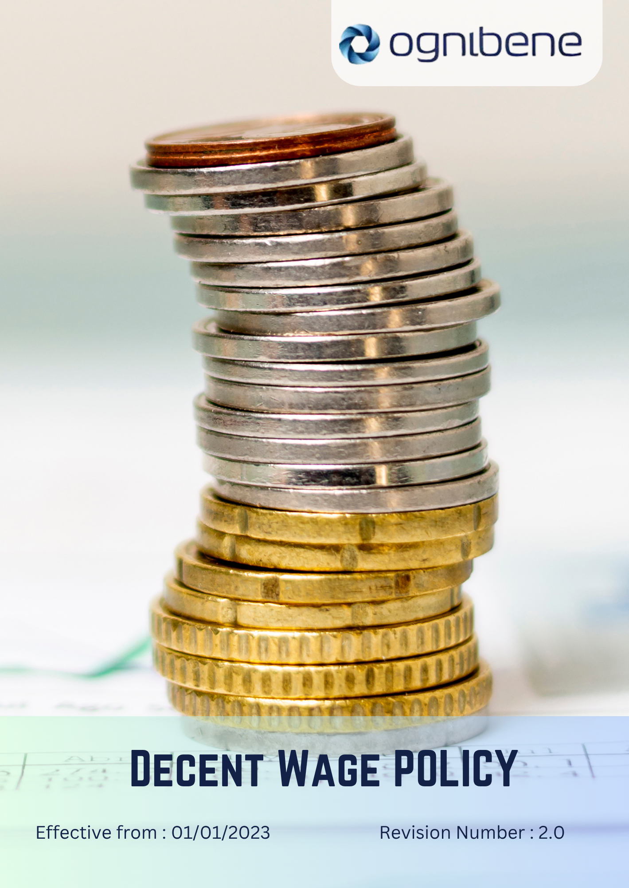

TABLE OF CONTENTS

Introduction 3
Scope 3
Policy Statement 3
Key Focus Areas 4
SDGs Covered 5
Responsibility 5
Review Mechanism 5
Revision History 6
Acknowledgement 7

Introduction
OGNIBENE INDIA PVT LTD, incorporated on February 10, 2006, is dedicated to designing and manufacturing hydraulic cylinders and hydraulic steering systems for off-highway vehicles, automotive, and marine applications. We are committed to ensuring that our employment practices contribute to the well-being of our employees and the communities in which we operate. This policy outlines our commitment to providing a living wage to all our employees and promoting fair compensation practices throughout our supply chain.

Scope
This policy applies to all workers, employees, directors, officers, agents, contractors, and any third parties acting on behalf of OGNIBENE INDIA PVT LTD (OIL). It covers all business activities, including employment, procurement, and any interactions with government officials, customers, suppliers, and other stakeholders. The policy is applicable globally, regardless of local business practices or cultural norms. This policy applies to the following locations:

Unit 1: | Ognibene India Private Limited – Pune Plant (I)  Plot A-13 Talegaon MIDC Village Ambi Navlakh Umbhre Talegaon, Pune Maharashtra – India
Unit 2: | Ognibene India Pvt. Ltd.  Unit No.A, B-600, Plot No.8, Ishanvi Industrial & Logistics 140402 Park, Vividha Ind.Park, Chamaru, Rajpura Patiala – Punjab – India

Policy Statement
Ognibene India Pvt. Ltd. is committed to ensuring that all employees receive a living wage that enables them to meet their basic needs and those of their families. We aim to promote fair compensation practices throughout our organization and supply chain while balancing economic sustainability with social responsibility.

Key Focus Areas
Below are our commitments and targets towards environmental sustainability as compared to baseline year 2023.
- Living Wage Implementation
Commitment: By 2030, ensure that 100% of direct employees receive a living wage, as calculated for their specific location and family size. Fair compensation awareness improves by 15% annually through structured workshops, training programs, and internal communication campaigns.
- Regular Wage Reviews
Commitment: Conduct biannual reviews of our wage structure to ensure it keeps pace with the changing cost of living. By 2030, we aim for 100% of employees to receive inflation-adjusted salary revisions within six months of any market cost increase. By introducing automated benchmarking tools, we ensure zero cases of delayed wage adjustments by 2030.
- Employee Benefits
Commitment: We aim to enhance total employee well-being beyond wages. By 2030, Ognibene India provides 100% medical insurance and retirement coverage for all permanent employees and ensures 80% participation in voluntary wellness and preventive health programs. By introducing a “Family Support Fund,” the company support 50 employee families annually for health, education, or emergency needs.
- Wage Transparency
Commitment: We maintain a transparent wage structure and provides employees clear visibility on pay bands and growth opportunities. Internal surveys demonstrate 100% employee satisfaction on pay fairness, and the company achieves zero wage-related grievances by 2030.
- Training and Development
Commitment: We invest in employee capability building, ensuring 85% of employees complete skill development programs annually. At least 40% of trained employees achieve role upgrades or pay increases based on performance. Cross-functional learning contributes to 25% of total training hours, focusing on productivity, digital skills, and career advancement.

- Wage Equity
Commitment: We uphold equitable compensation practices, maintaining a maximum 15:1 ratio between the highest and lowest paid employees. The gender pay gap remains at 0% unexplained variance, and annual equity assessments enhance pay transparency awareness by 30% across the organization.

SDGs Covered
OIL is committed to achieve the following Sustainable Development Goals:

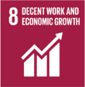


Responsibility
The Human Resources Officer (HRO) is responsible for overseeing the implementation of this policy, ensuring that employment practices align with living wage objectives. The Compensation and Benefits Manager will conduct regular wage analyses and adjustments to ensure compliance with the outlined standards. Additionally, the Sustainability Manager will collaborate with suppliers to promote fair wage practices, provide necessary guidance, and track progress toward achieving the quantitative targets outlined in the policy. All managers and team leaders are responsible for integrating these standards into daily operations and employee interactions.

Review Mechanism
This policy will be reviewed bi-annually by the Human Resources Officer (HRO), Sustainability Manager, and Finance Director to ensure it remains current with evolving economic conditions, living wage calculations, and industry best practices. Necessary updates will be communicated to all stakeholders, and any required changes will be implemented promptly.

Revision History
Revision No. | Date | Description of Changes | Approved By
0.0 | 01 Jan 2023 | Initial Policy Draft | General Manager Operations
1.0 | 01 Jan 2024 | Updated Scope and add the Acknowledgement section | General Manager Operations
2.0 | 01 Jan 2025 | Updated Key Focus Areas revised with action-oriented commitments and introduced the Revision History table | General Manager Operations

Approved by: General Manager of Operations
Last Review Date: 01 JAN 2025 Next Review Date: 01 JAN 2027

Acknowledgement
I, _________________________, acknowledge that I have read, understood, and agree to adhere to the company's Living Wage Policy. I recognize the importance of my role in supporting the company's commitment to fair compensation practices and am committed to actively participating in the implementation of this policy. I will strive to incorporate living wage principles into my daily work activities, comply with all relevant regulations and company policies, and support the continuous improvement of our social performance.

I understand that my commitment is essential in achieving the company's objectives for fair compensation and fostering a culture of equity and social responsibility. I am dedicated to contributing to our shared vision of a sustainable and fair workplace and demonstrating our dedication to employee well-being.

Employee Name:
Employee Signature:

